**Design of the Experiment**

**Between-subjects design:**

**Design**: A single (*Manipulation*: No Bag Info) within-subject design. One method factor counterbalanced across participants:

* + - *Order of evaluative measures*: IAT before vs. after self-reports

**Stimuli.** Two unknown male images (respectively labelled Chris and James) serve as TARGET1 and TARGET2. Ten positive (*Fantastic, Wonderful, Honest, Kind, Brave, Amazing, Nice, Pleasant, Selfless, Great*), ten negative adjectives (*Horrible, Nasty, Violent, Terrible, Hated, Disgusting, Mean, Unpleasant, Stupid, Bully*) will serve as Source stimuli.

**Participants.** Data-collection will be via the Prolific website (prolific.achttps://prolific.ac/). We will stop data-collection as soon as 100 participants have completed the experiment on the Prolific website. Recruiting 100 participants will allow us to have good power (> 0.80) to observe a small effect (*d* = 0.30) at alpha = 0.05. We decided to collect additional participants in order ensure that the necessary sample size was still obtained after exclusions.

**Procedure.**  *Acquisition phase 🡪 Evaluative measures 🡪 Exploratory Questions*

*Acquisition phase*. Participants receive three blocks of 12 trials (36 total) consisting of four different types of trials: those that presented (a) TARGET1, (b) TARGET2, (c) a positive word, or (d) a negative word. Each trial involved the presentation of the stimulus by itself in the middle of the screen for 4000ms. After each trial a 2000ms intertrial interval was presented where no stimulus appeared on the screen. The order of stimulus presentation was random in order to ensure that there was no contingency between the presentation of one stimulus and another.

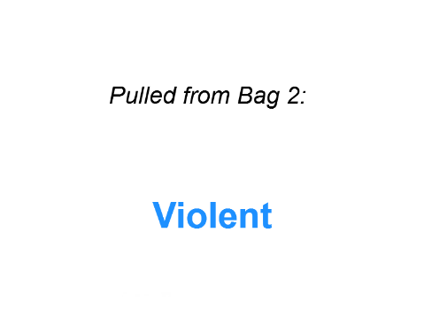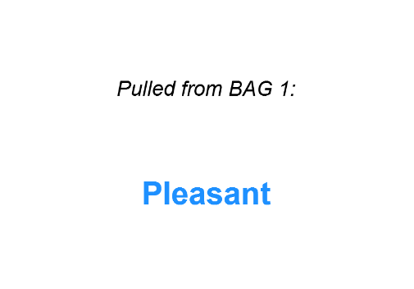

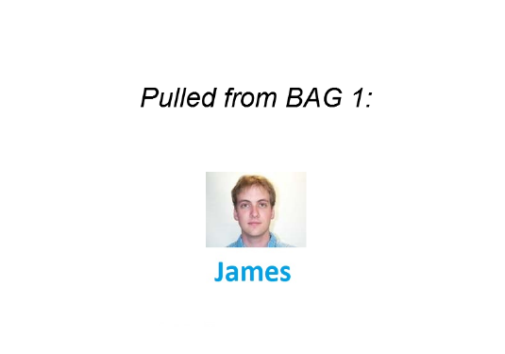

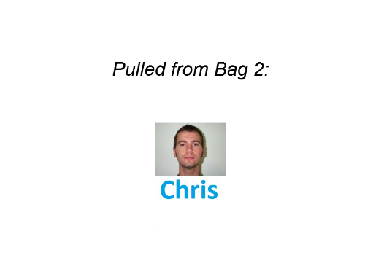

*Figure 2*. Example of the four trial-types encountered during block 1 of the acquisition phase.

Instructions prior to the acquisition phase indicated the following:

*“The computer will show you a word or image.*

*PLEASE PAY ATTENTION TO THE WORDS AND IMAGES THAT APPEAR*

*You will be asked questions about these later on.**”*

**Automatic evaluations**

Participants will perform an IAT measuring implicit evaluations of TARGET1 vs. TARGET2:   
The IATs involve categories “TARGET1” and “TARGET2” and “Good” and “Bad”  
  
IAT Procedure:

a. Instructions: “In the next part you will have to categorize items into groups as fast as you can.”

b. 20 practice trials sorting TARGET1 on the left and TARGET2 on the right.   
  
c. 20 practice trials sorting positive words on the left and negative words on the right.

d. 20 test trials TARGET1 and positive words Sources using one key and TARGET2 and negative words Sources using another key.

e. 40 test trials TARGET1 and positive words Sources using one key and TARGET2 and negative words Sources using another key.

f. 20 practice trials TARGET2 on the left and TARGET1 on the right.

g. 20 test trials TARGET2 and positive on the left and TARGET1 and negative on the right.

h. 40 test trials TARGET2 and positive on the left and TARGET1 and negative on the right.

NOTE: IAT stimuli are:

* + - TARGET1 (image of Chris)
    - TARGET2 (image of James)

Positive words: *Confident, Loving, Cheerful, Loyal, Generous, Happy, Likeable, Warm*

Negative words: *Liar, Cruel, Evil, Ignorant, Manipulative, Rude, Selfish, Disloyal*

*Self-reported evaluations*. Participants will be shown an image of TARGET1 or TARGET 2 and asked the following questions:

*“Please indicate how you feel about this person*   
options: -5 =Negative, 5= Neutral, +5= Positive

options: -5 =I Dislike him, 5= Neutral, +5= I Like him

options: -5 =Bad, 5= Neutral, +5= Good

options: -5 =Unpleasant, 5= Neutral, +5= Pleasant

*Exploratory questions.*

*Manipulation check*. “Did you ever take notes (or write down) what happened in order to help you figure out what was going on? Please be honest here (you will receive payment regardless of what you say).”

*Demand Compliance (explicit):* "Earlier you rated Chris and James as being either positive, neutral, or negative. Did you base your response on how you actually felt about those individuals OR on what you thought the researchers wanted you to say?"

How I actually felt about Chris and James", "What I thought the researchers wanted me to say (i.e., not on how I personally felt)", "I don’t know")

*Demand compliance (implicit).* Earlier you completed the Implicit Association Test (see below). Did you base your performance in that task on your best efforts to perform the categorizations as quickly and accurately as possible? Or did you attempt to influence your speed or accuracy in order to go along with what you thought the researchers wanted you to feel about the words?"

("I tried to perform the task as quickly and accurately as possible", "I tried to alter my performance based on what I thought the researchers wanted to find", "I don’t know")

*Reactance. (Explicit).* Earlier you rated Chris and James as being either positive, neutral, or negative. Did you consciously resist what you thought the researchers wanted you to feel about those individuals?"

("Yes", "No", "I don’t know")

*Reactance (implicit).* Earlier you completed the Implicit Association Test (see below). Did you try to influence your speed or accuracy in order to consciously resist what you thought the researchers wanted you to feel about those individuals"

("Yes", "No", "I don’t know")

*US awareness*. "In Part 1 of the experiment the computer showed you a series of words and images. Did the computer show you words that...?"

Response options. ("always had a positive meaning", "always had a negative meaning", "had different meanings (e.g., some positive, some negative)", "I don’t remember")

*Influence awareness.* "Do you think the stream of positive and negative words that were presented along with images of Chris and James in Part 1 of the experiment influenced how much you like or dislike Chris or James? Please be honest here"

Response options. Open-ended.